INFO 3401-Kexin Zhai

**Monday**

1. This script converts Images into ASCII Art and there is a cat.

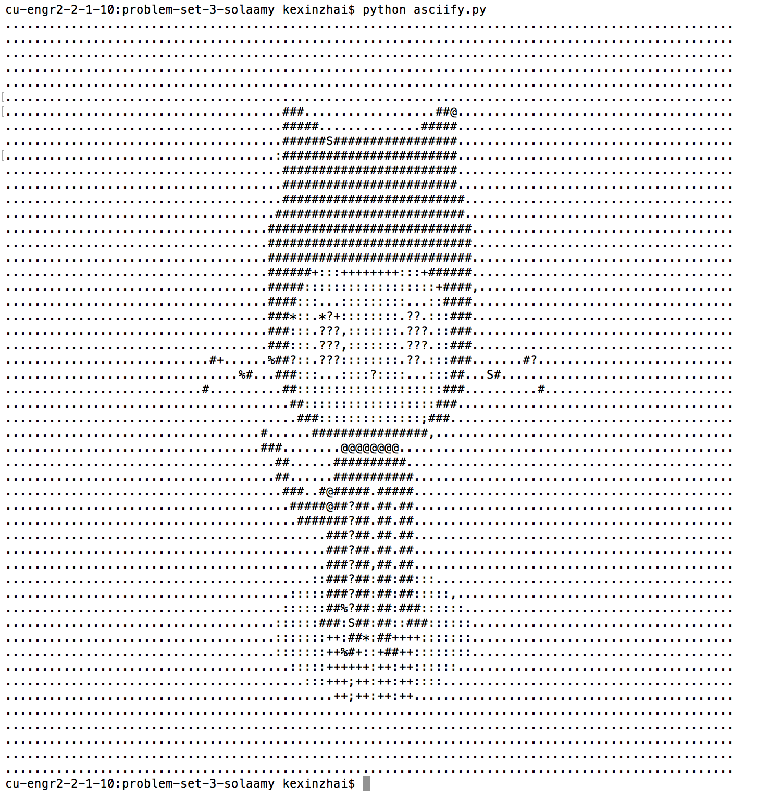

1. Command: pip install delorean

It prints:

Delorean(datetime=datetime.datetime(2018, 9, 10, 16, 32, 39, 379107), timezone='US/Eastern')

The real-time on US Eastern time zone

1. cuel -0 <http://www.colorado.edu/>

wget [http://www.colorado.edu](http://www.colorado.edu/)/

1. grep Colorado index.html -c

17 lines were found

1. cat index.html | grep Colorado > search_results.html

**Wednesday**

Three datasets:  
Student’s GPA, Regularity of student go to the gym/Information of students who go to the gym, the frequency of facilities being used.

Context: (The defining frame of the problem)

CU would be the main stakeholders. CU want to justify that regular gym attendance can lead to a higher GPA. CU are trying to understand how they might update their services and facilities to encourage students to go to the gym. For the project, CU wants us to make use of data to understand the current state of gym use and its potential effects on students, and how CU might target specific facilities or programs to improve attendance. CU students would be the target audience.

Needs: (The problems or challenges addressed directly by the data)

We would know if regular gym attendance can lead to a higher GPA. Further, we would understand how frequently the gym being used and how strong the potential effects the gym is on students, especially on academic. The results would give CU an analysis of how they might update their services and target specific facilities to improve attendance of the gym.

Vision: (An actionable plan for how we will address the stakeholders needs to achieve our goals)

We could use the datasets provided from CU to analyze and receive the results. We could analyze the dataset of students who go to the gym more than once. Based on the results from this dataset, we will know their GPA and the frequency that students go to the gym. In order to have a clear thought, we could create data visualization graphic to show the relationship between students’ GPA and their frequency of going to the gym. Also, we will have a graphic shows the frequency of use for each facility or program in the gym. Data visualization will include the graphic that presents the amount of people enter the gym in different periods of the day. We will have the data that shows the current state of gym use and which facilities could be improved and attract more student going to the gym.

Outcome:(The actions that will come from achieving our vision)

The results would show how CU could improve their services and give a thought of what kinds of facilities or programs could be improved to attract more students to be active. Based on the most popular time period during the day, the time period that most students choose to go to the gym, CU could hold more attractive events during that period and encourage more students to attend. After presenting the results, CU might choose if they will take action to improve their services or facilities based on our reports. CU will go on handling the data next.

**Friday**

* In 1956, People needed to consider the constraints of hardware memory when processing data. User data was available. German physicist Fritz-Rudolf Güntsch developed the concept of virtual memory as an idea that treated finite storage as infinite. “Storage, managed by integrated hardware and software to hide the details from the user, permitted us to process data without the hardware memory constraints that previously forced the problem to be partitioned”. I think I would transfer the data to the cloud, in case it doesn’t lose. Nowaday, some data could be storage not only in hardware but also through internet.
* In 1865, in business field, people want to find out a way to do better than their competitors. “The term “business intelligence” is used by Richard Millar Devens in his Encyclopaedia of Commercial and Business Anecdotes, describing how the banker Henry Furnese achieved an advantage over competitors by collecting and analyzing information relevant to his business activities in a structured manner. This is thought to be the first study of a business putting data analysis to use for commercial purposes.” For me, besides analyzing relative information to the business activities, I would also analyze the big market data to receive the results which shows the trend of business.
* Back to 250 years ago, there were a lot of datasets but the knowledge of data analysis had not been used. People didn’t realize they could gain useful information from the big amount of datasets. “Richard Price was also one of the scientists who initiated the use of statistics in analyzing social and economic datasets. Since the 1950s, as computing technology has gradually been used in commercial applications, many corporations have developed databases to store and analyze collected data.” They created the method to analyze data. For me, I will use different method not limited to computing technology to analyze data.